DRAFT Letter to EPA, IEPA and Health Department

Introduction - who is sending this? When what is our tone?

[we residents of LaSalle are concerned about the safety of ongoing exposures to materials released during the explosion and fire. We believe that the testing performed to date has been incomplete and that more careful study should be conducted to ensure that we will not be exposed to harmful chemicals, including heavy metals from the historic emissions or fire related byproducts spread throughout our town.

The LaSalle community has many reasons for requesting additional testing in order to better understand the potential and actual health impacts resulting from the fire and explosion at the Carus LaSalle Site. There are many gaps in information and data collected to date as further explained below. In summary:

- Furnace filters gathered by Sierra Club and community members indicate that significant amounts of manganese and other metals have been airborne in our community while the initial report by Brownfield only included manganese and potassium. Review of continuous monitoring adjusted data for PM2.5 gathered from a Purple Air monitor located at the LaSalle Library, indicates 1) a significant increase in 3-hour averages the day of the fire and 2) slowly increasing levels as Carus brought portions of their processes back online. [insert or attach graphs?]

- US EPA air monitoring the event indicated high levels of particulate, but did not include assessment of airborne metals, which are of significant concern to the community. The monitoring was not continuous and results were compared to an OSHA workplace standard that does not appear to be applicable to a residential area. [insert or attach graphs?]

- Levels of metals in soil in the community are above background median values nationally, and on par with those in highly-impacted communities. A recent study, Pathways of Inhalation Exposure to Manganese in Children Living Near a Ferromanganese Refinery, in Marietta, Ohio, indicates median soil manganese (Mn) levels of 552 mg/Kg and the maximum level as 2,229 mg/Kg. The median level in soil in LaSalle is 675 mg/Kg and the maximum to date is 1,560 mg/Kg. Further testing is necessary in homes not already addressed by the Superfund remediation, including public spaces, private yards and gardens.

- IEPA surface sampling is limited to a small number of wipe samples. These are hard to interpret and the implications of the measurements provided are unclear. Air filter sampling is more indicative of recent emissions and metals that could have entered the home environment.

- There has been incomplete assessment of the impacts to waterways. Water quality testing was performed by collecting surface water immediately following the fire. The metals in the run-off from the fire would have quickly sunk to the sediment. Testing up- and downstream sediment is needed in order to assess long term loading and impacts to the Little Vermillion River.

- Communication has been poor. None of the homeowners where wipe samples were collected have received written communication from the Illinois Department of Public Health (IDPH).

The community believes that further testing is required to fill in the gaps that remain in the data from testing performed by IEPA, EPA and IDPH. As outlined below, some data was not complete, may not be compared to all appropriate criteria and there is no attention to the potential cumulative exposures that homeowners and particularly vulnerable individuals and children, have been exposed to. The inhalation route from metals that remain in furnace ducts and on surfaces in homes is of particular concern.

Home air filters collected by community members and analyzed by Merit Lab in East Lansing, MI indicate elevated levels of airborne heavy metals in the recent past

Seventeen (17) home furnace filters have been tested by Sierra Club and the local community. Attachment 1 details the collection of samples, the protocols for filling out the chain-of-custody, packaging samples and managing express overnight shipment to the lab were all directed by a person with more than 30 years’ experience with environmental sampling at industrial facilities. Merit Lab is certified in analyzing all sampling that has been received. Specifically, they used EPA Method 200.8 for analysis of metals on furnace filters and EPA method 245.1 for analysis of Mercury. We are happy to provide the reports and QA/QC if requested.

Furnace filters and soil samples have been plotted on a map and indicate that homes north and northeast of Carus are well represented. The following screenshot shows the most highly impacted homes in yellow and less impacted in blue. There is a clear lack of information for homes south and west of Carus. This gap in data is of concern and further testing of home furnace filters south and west is needed.

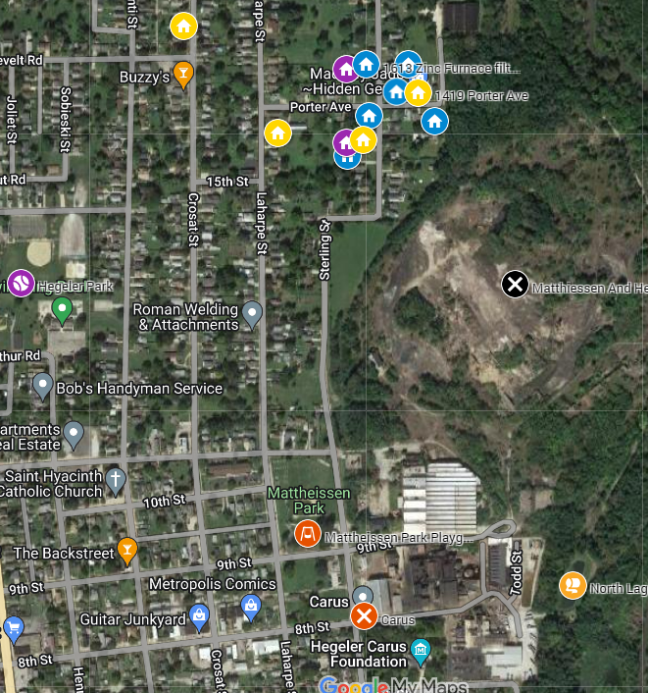

Important additional information from homeowners where filters have been tested includes the life of the filter and post-changeout retesting results. For example, one of the more highly impact filters was from a home where the filter had just been changed prior to the fire [confirm - Brianna]. Another homeowner described that their filter was tested after the fire, was replaced with a new filter, and resampled a month later. Her comment was that the new results indicated the new filter was “75% loaded again” [confirm w/Jamie - who was that talking?]. Yet another homeowner several blocks northwest of Carus had a filter that was new only 2 weeks before the fire and metals were found on the filter. When told by an EPA representative that the metals were likely “naturally occurring”, the homeowner responded, “If that is true, a furnace filter at the west end of Peru that is similar to mine should show all the same results. However, the EPA has shown no interest in establishing a control group well outside of the affected area. Why is that?”

These facts, in conjunction with the ambient air small particulate matter (PM2.5) data discussed below, confirms that the contribution of metals and PM2.5 by Carus was significant during the fire and apparently during normal operations.

IEPA incorrectly claims air monitoring performed by USEPA did not detect any substances at levels of concern.

IEPA reviewed only particulate matter data, which doesn’t reflect the toxicity of airborne metals. The PM2.5 measurements on February 11th and 12th exceeded the 24-hour standard for PM2.5 is 35 ug/m3 (ppb), measuring a maximum of 100 ppb and an average of 47 ug/m³.

The EPA data is presented in a misleading way. The ambient air readings because the results from the 11th and early on the 12th are given in mg/m³ (ppm). Ambient air quality standards are expressed in ug/m³ (ppb) and using mg/m3 is deceptive because people don't always understand that they need to multiply by 1000 to know what the readings are in ppb for a more direct comparison. The results later in the day on the 12th are in ug/m³.

Per Robert Kondreck, from EPA’s Superfund Program: "EPA did not deploy continuous monitoring and therefore we are not able to calculate a 24-hour average that can be compared to an AQI. Instead, they did rotations at A-01 through A-04 using a hand held particulate meter and compared it to an 8-hour OSHA number (0.5 times the particulates otherwise not regulated or 2,500 ug/m3)." We do not believe that an 8-hour OSHA standard is applicable to ambient air emissions and exposures to the community during an emergency event. In our research, the only time that OSHA weighs in on particulate matter outside of the workplace is employee exposure to PM during wildfire events. For example, CalOSHA states, "An AQI over 150 is considered unhealthy for the general population. AQI over 101 can be unhealthy for sensitive groups and some workers with asthma and other conditions may feel unhealthy when the AQI is below 150.” A respirator is required in all cases above 101 ug/m3. Oregon has similar requirements for workers. Comparing a captive homeowner’s exposure to ambient air 2.5 micron particulate matter to an industrial worker that would be required to wear respiratory protection is not acceptable and does not appear to be a common practice. An explanation of the source of this criteria is requested.

The LaSalle Public Library, located southwest of Carus has a Purple Air monitor that does continuously monitor PM2.5 emissions. The Library provided the community with readings from this monitor from January 1, 2023 through April 8, 2023. The data was corrected as recommended by both EPA and the National Institute of Health (NIH). The 24-average PM2.5 result from the Library monitor from 9 AM on January 11, 2023 to 9 AM on January 12, 2023 was 39 ug/m3. The following graph illustrates 3-hour averages before, during and after the fire.

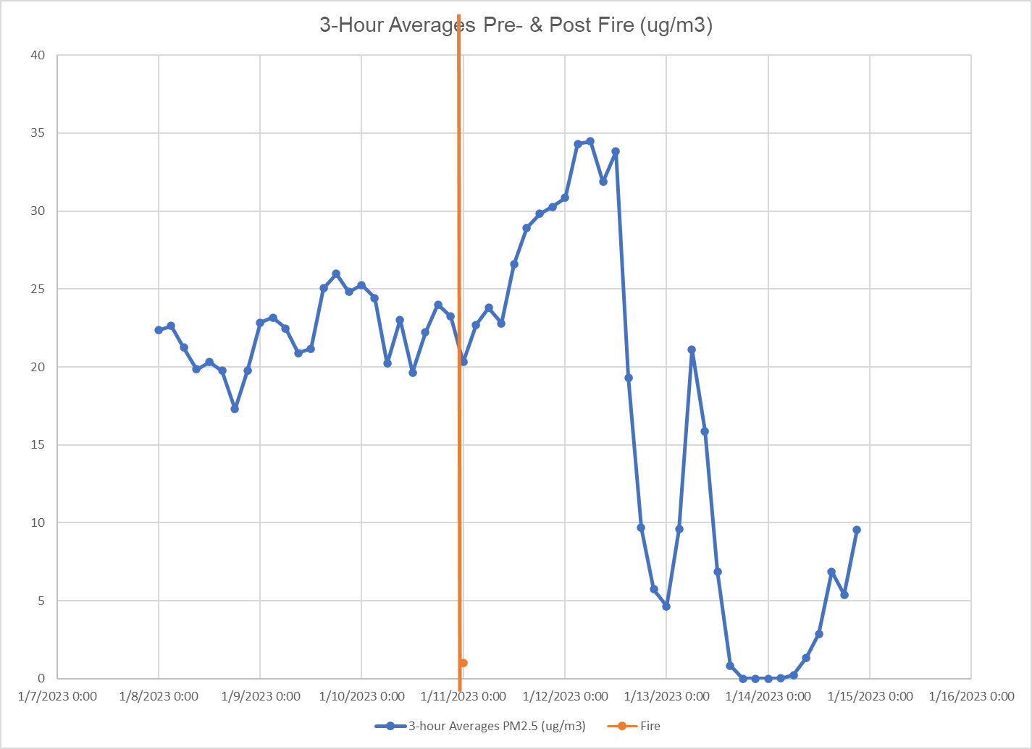

Brownfield Engineering results are too limited to draw conclusions about environmental exposures for the LaSalle community.

The problems with the data include:

The February 2023 samples were collected at a depth of about 6 inches. This is too deep for samples that were collected so close to the event and where the intent should have been to determine and assess the worst-case potential exposure to LaSalle residents. The samples should have been from the top 0 to 3 inches of surface soil.

Brownfield only had the initial January 2023 soil and water samples analyzed for potassium and manganese when they should have known that there were likely other metals in the fallout from the fire given the Carus site operations, intermediate and finished products stored.

The February and March 2023 soil samples performed by Brownfield are all being compared to values assessed specifically for the Superfund site. There is confusion about what is being assessed as contamination from the Matthiessen And Hegeler Zinc superfund site and what was likely caused by the Carus fire event. One community member expressed their concerns as follows:, “What can be done to encapsulate, contain, or tamp down the soil or other existing contaminants from the M&H site to the point where future sampling taken is a reflection of Carus Chemical emissions, soil contaminants, etc., only. It seems that any effort to monitor the Carus Chemical plant or bring them into compliance is and has been severely hampered by their ability to point a finger at the Superfund site.” There needs to be some discussions and fact-based consensus and conclusions made by the EPA and Illinois EPA regarding which homes were previously impacted by the superfund site and were not cleaned up and those that have clearly been impacted by Carus, so that the appropriate criteria can be used. Superfund site criteria for yards and gardens do not appear to apply to many of the sites where contamination has been found in soil by Brownfield testing. Performing additional sampling west and south of Carus would help the community better understand the actual impacts from the Carus fire versus former superfund site impacts.

Further to this argument, there is data that indicates the Matthiessen And Hegeler Zinc superfund site may not be a significant source of PM2.5 or metals in ambient air, surface soils, and/or other outdoor surfaces. The Library data mentioned above also indicates a profile of PM2.5 in ambient air that rises and falls with partial production activity at Carus. Carus reports that “Carus LLC resumed production and shipping of phosphates” on January 20, 2023. On February 17, 2023, they reported that “Carus LLC resumed production of CARULITE® catalysts”. It is our understanding that these are not full operations or shifts. The following graph shows 24-hour average ambient PM2.5 emissions from January 1, 2023 through March 15th, 2023, with milestones showing the emissions profile during the fire, after phosphate production starts up on January 20, 2023, and after February 17, 2023 start-up of catalyst manufacturing. There is an obvious increase in atmospheric PM2.5 as Carus brings the facility back into production. Continued tracking of PM2.5 as Carus comes up to full production will help the community confirm what appears to be true. That is, that Carus’ normal operations and emissions contribute to ambient PM2.5 air quality and that fenceline monitoring should be required.

In 2018 the U.S. Environmental Protection Agency and the U.S. Department of Justice finalized a consent decree with S.H. Bell Company, requiring the company to monitor and take measures to reduce manganese emissions from its 92-acre plant that spans the Pennsylvania-Ohio border in Ohioville, Pa. and East Liverpool, Ohio. The consent decree required S.H. Bell to set up a fenceline air monitoring system to measure the respirable manganese concentrations.

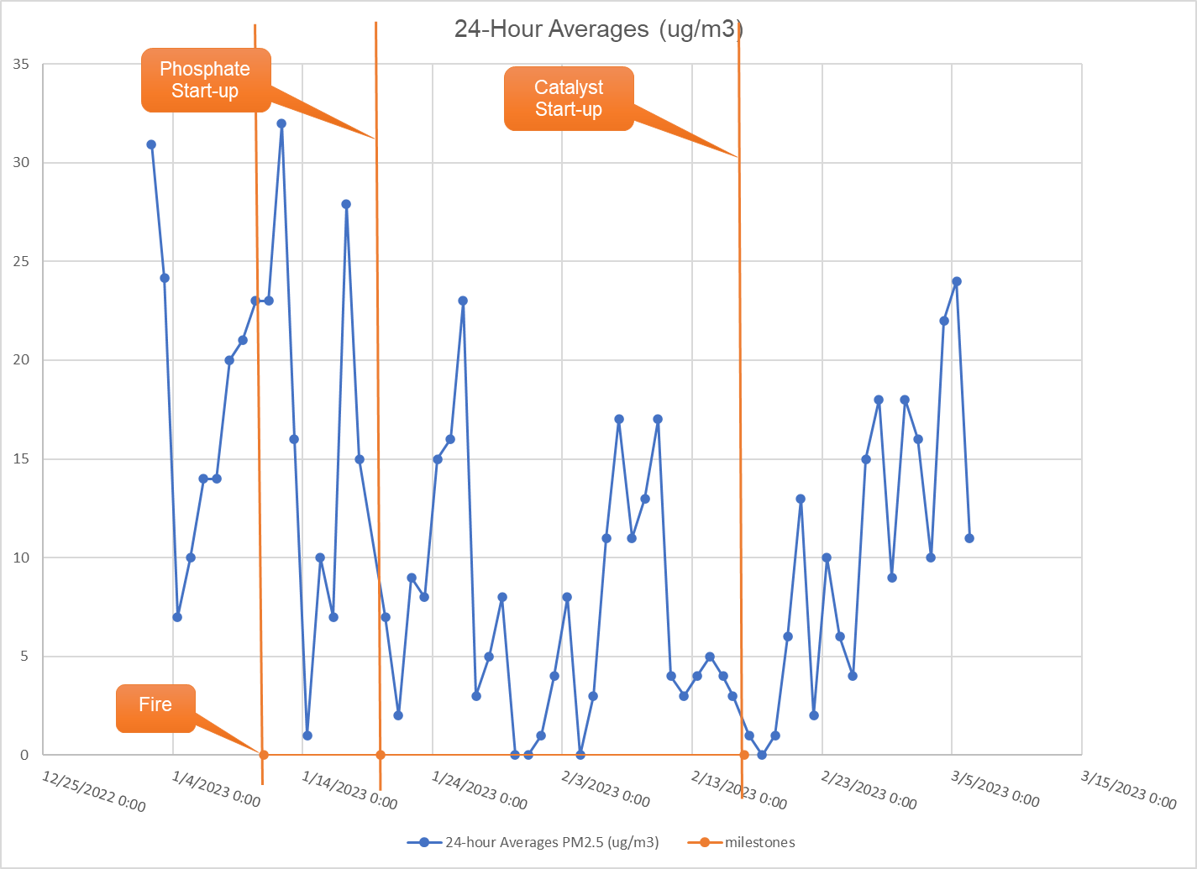

The cumulative impacts from various exposure pathways to metals in dust and soil, and particularly manganese, are of great concern to the community.

Brownfield has presented, and the Illinois EPA has agreed that, levels of metals in soil are below criteria. The community remains concerned that their yards, their gardens and places where they play ball or take their children to play are contaminated and that the cumulative impacts might be harmful to them and their families. The community is concerned that the extent of manganese is soil and that remains in their furnace system ductwork has not been fully assessed. This is, in part, because every time samples are collected, more unsettling results are found. Matthiessen Park Playground was sampled by Brownfield on March 9, 2023 and manganese levels are very near residential criteria (1560 mg/Kg vs criteria of 1600 mg/Kg) and nearly 2.5 times the manganese median background level of 630 mg/Kg. Further delineation and possible clean-up needs to happen.

The fact that Manganese is in a playground where children frequent is yet another example of how many ways and how many places there are where children might be repeatedly exposed to harmful levels of metals in this community. Elevated levels of Manganese (Mn) in soil or dust pose a significant hazard, especially through chronic inhalation, and especially to children. Children crawl on the floor, put things in their mouths, sometimes eat inappropriate things (such as dirt or paint chips), and spend more time outdoors. Children also are closer to the ground, and they do not use the judgment of adults to avoid hazards (NRC 1993). None of the data or assessments presented to the community to date provide assurances that all possible routes of exposure have been assessed. There are gaps in the data that must be closed and all results communicated to the community.

There are many epidemiological studies regarding children where there are levels of Mn in soil in those communities that have been traced to levels of Mn in their hair. Some of those studies have traced the levels of Mn to neurocognitive outcomes. The Center for Disease Control (CDC), through work performed by the Agency for Toxic Substances and Disease Registry (ATSDR) put together a Toxicological Profile for Manganese. In it they state that, “in several studies of children, associations have been reported between manganese concentrations in blood or hair and motor impairment and deficits in neurodevelopment and intellectual functions.” More than ingestion in drinking water, studies have found that inhalation of Mn is of particular concern. This ATSDR study found that the mean concentration of manganese in ambient air in the United States is 0.02 μg/m3; however, ambient levels near industrial sources can range from 0.22 to 0.3 µg/m3.

One recent study, Pathways of Inhalation Exposure to Manganese in Children Living Near a Ferromanganese Refinery, further supports that inhalation is of particular concern for children. The 2017 study further supports the idea that inhalation of manganese (Mn) is of particular concern for children. Highlights from the study include 1) that levels of Mn in air and soil and the time that children spend outside significantly contributed to Mn levels in household dust and 2) Mn in household dust was found to be a significant contributor to levels of Mn in children’s hair. This study was performed in Marietta, Ohio, and the median and maximum levels of Mn in soil near the homes were very similar to what is being found in LaSalle. Median soil Mn levels in the Marietta study were 552 mg/Kg and the maximum level reported as 2,229 mg/Kg. The median level in soil in LaSalle is 675 mg/Kg and the maximum to date is 1,560 mg/Kg. The latter result is very close to the Illinois Residential Ingestion Remediation Objective of 1,600 mg/Kg and was found in a soil sample collected at the Matthiessen Park playground, posing an additional exposure risk to children and the community that frequent the Park.

The off-site sampling was not sufficient to rule out water quality impacts related to the fire nor any direct discharge from the facility to the river.

The up- and downriver sampling indicated a very slightly higher level of Manganese downstream. The metals that might have been in water before and subsequent to the fire and that made it to the river would likely not have been present in surface water but would have since sunk to the sediment. Up- and downstream sediments should be tested for relevant metals. It is the only and best way to determine if Carus has adversely impacted the Little Vermillion River. The IEPA’s own photo log indicates that some impacted water might have left the site. The private pond would be similar in that the metals would have sunk to the pond sediments.

The IEPA alleges that “sampling to date appropriately characterized the impacts from the fire, the agency does not believe that further testing is warranted, including for indoor air quality. It would be difficult to attribute the results of indoor air pollution to a specific cause.”

The community has general concerns about the lack of consideration to cumulative health impacts to vulnerable populations and risks to children. Besides comparing each result to some criteria, cumulative impacts are something that needs to be considered by the responsible parties. Many of the symptoms of over-exposure to these metals are common and result in similar endpoints and so, in a cumulative or additive manner, can be more harmful in combination.

We request more careful characterization of the combustion by-products and heavy metals released from the Carus site, both over time and during the fire. Carus’ normal operations and emissions appear to contribute to ambient PM2.5 air quality and fenceline monitoring should be required. LaSalle should continue to assess PM2.5 monitoring results from the Library Purple Air monitor following full production at the Carus Site. The Illinois EPA Division of Air Pollution Control (DAPC) should assess current permit conditions, Carus’ compliance with those terms & conditions and consider adding additional requirements for fugitive particulate matter, including periodic monitoring and fenceline monitors.

Additional testing of furnace filters and surface soil is needed in homes and facilities where vulnerable populations live or frequent, south and west of the Carus Site.

Further delineation of levels of Mn in soil in Matthiessen Park and playground is recommended regardless of who will be responsible for follow-up. Based on those results, a determination to remediate should be considered. The community should be kept informed of any additional information as it becomes known and portions of the park closed if deemed necessary.

Residual dust in home furnace system ductwork will continue to cycle through home heating and cooling systems and will settle on surfaces in the home, including where children play. Surface dust will continue to contribute to indoor air because it can also be re-entrained and recirculated throughout the home. Sampling ambient indoor air quality for Mn would not be helpful unless performed over time, for extended periods of time, and in conjunction with surface dust sampling. For these reasons, surface sampling for Mn inside homes is recommended and will provide additional information about ongoing inhalation hazards inside people’s homes. In the 2017 Pathways of Inhalation study referenced above, interior floor dust samples were collected from three sites within the residence. The preferred sites were the front or most used entry of the home, the kitchen, and the room where a child or children spends the most awake time (e.g.; living room, bedroom, or playroom). A similar plan is recommended in LaSalle.

Up- and downstream sediments should be tested for relevant metals in the Little Vermillion. The private pond would be similar in that the metals would have sunk to the pond sediments.

PurpleAir PM2.5 U.S. Correction and Performance During Smoke Events
Correction and Accuracy of PurpleAir PM2.5 Measurements for Extreme Wildfire Smoke
Soil & Water Sampling Report City of LaSalle, IL, Carus Chemical Co. Fire Precipitation, Brownfield Environmental Engineering, February 7, 2023
LaSalle Analytical Summary Tables 3-24-2023
Toxicological Profile for Manganese
10.1016/j.scitotenv.2016.11.030

